1. Write a function to calculate the total pay of a waitress where the rate of pay (thousand VND / hour) and the number of hours. It is supposed that the number of hours is up 40, the waitress is paid at basic rate, and above 40 at double rate. Test your code in main function.
2. The function:

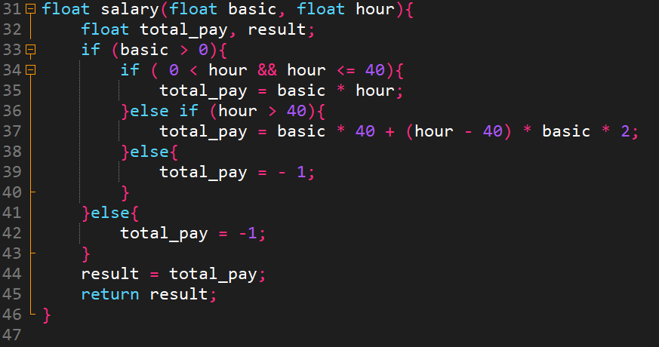

1. Call the function in main function:

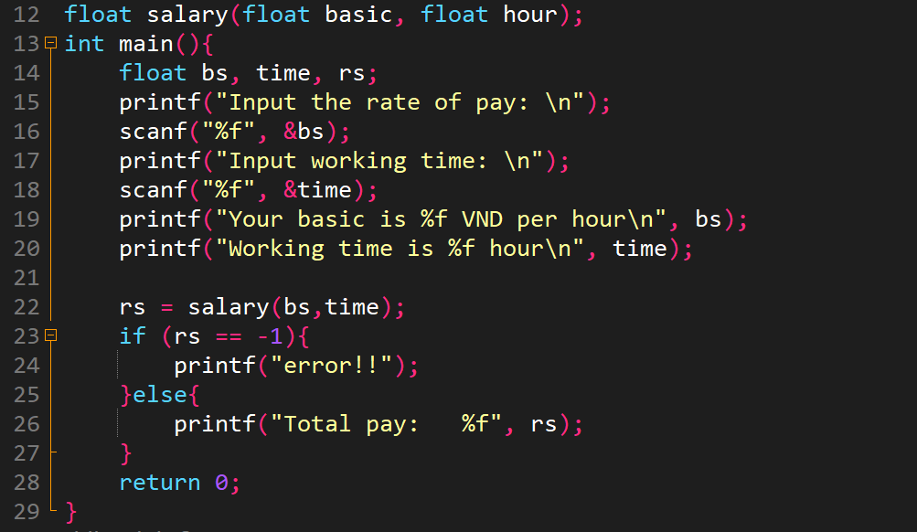

1. Test:

* Case 1:

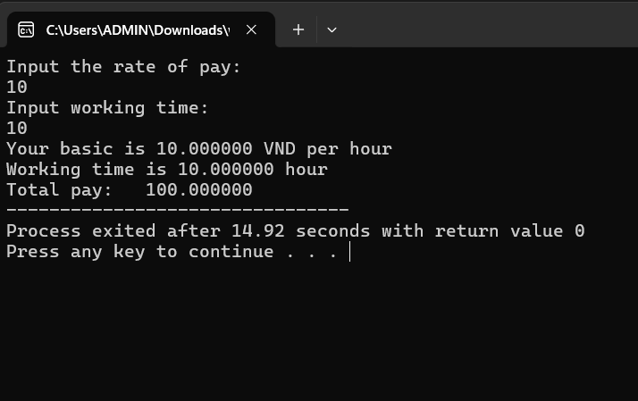

Walkthrough:

Line 16: enter 10 from keyboard 🡪bs = 10

Line 18: enter 10 🡪 time = 10

Line 22: pass bs & time to salary function 🡪basic = 10, hour = 10

Line 33: hour = 10 🡪true🡪execute condition command

Line 44: assign total_pay to result variable

Line 45: function return result

Line 22: assign result of function to rs variable

Line 26: print out on screen

* Case 2:

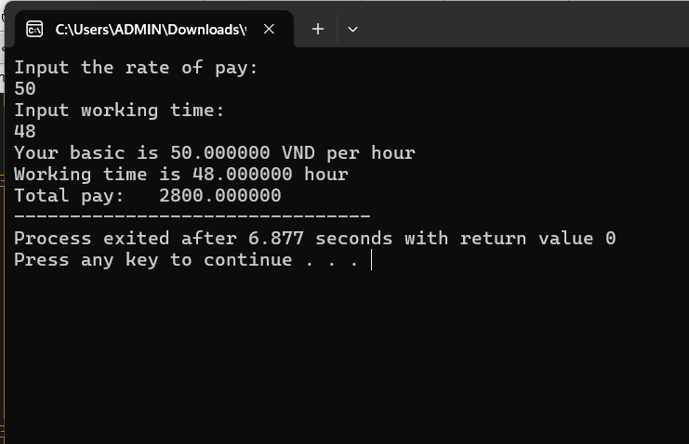

Walkthrough:

Line 16: enter 50 🡪 bs = 50

Line 18: enter 48 🡪time = 48

Line 31: pass bs and time variable to salary function

Line 36: true🡪 execute condition command

Line 45: the function return result

* Case 3:

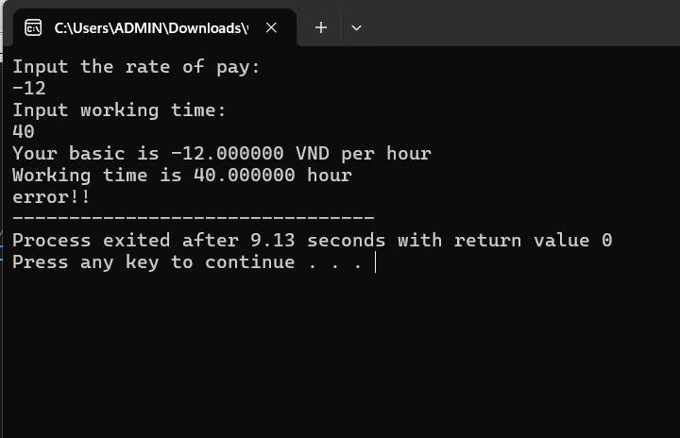

Walkthrough:

Line 16: enter -12 🡪 bs = -12

Line 18: enter 40 🡪 time = 40

Line 31: pass bs and time variable to salary function

Line 33: false🡪execute line 41🡪assign -1 to total_pay

Line 45: function return result assigned by total_pay

Line 23: true 🡪 execute condition command

Line 24: print out on screen

1. Write a function to generate an array containing square numbers given the number of elements. Test your code in main function
2. The function:

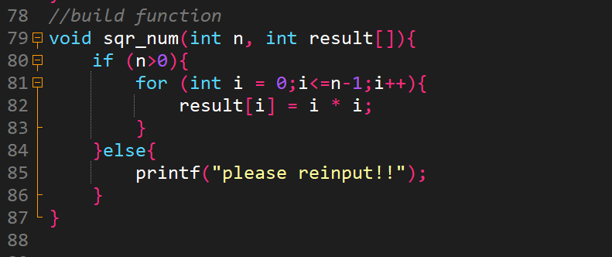

1. Call the function in main function:

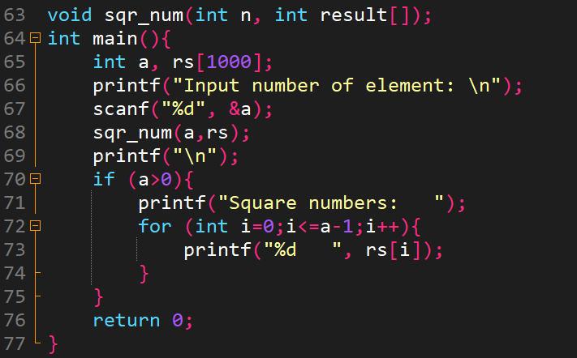

1. Test:

* Case 1:

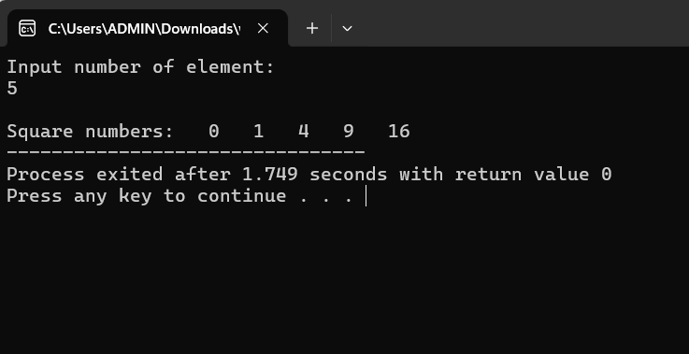

Walkthrough:

Line 67: enter 5 from keyboard 🡪a = 5

Line 68: pass a to sqr_num function

Line 81: execute loop command 🡪i=0🡪result[0] = 0*0 = 0

🡪i = 1 🡪 result[1] = 1*1 = 1

🡪i = 2 🡪 result[2] = 2*2 = 4

…

Line 73: print out on screen

* Case 2:

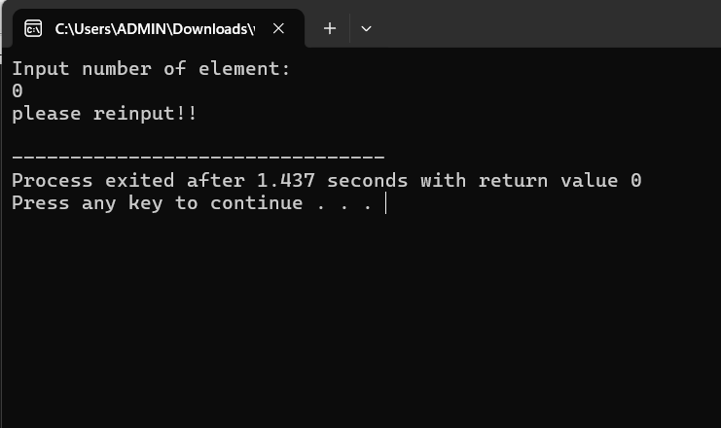

Walkthrough:

Line 67: enter 0 from keyboard 🡪a = 0

Line 68: pass a to sqr_num function

Line 80: false 🡪 execute else command 🡪line 85: print out on screen

1. Write a function to generate a new array containing the element of a given array where two elements k and k+1 in a given array are swapped. Test your code in main function.
2. The function:

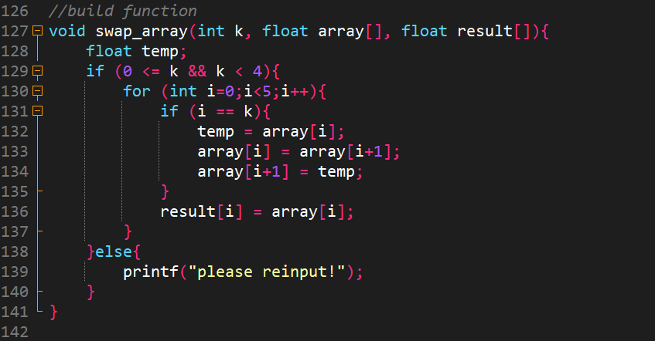

1. Call the function in main function:

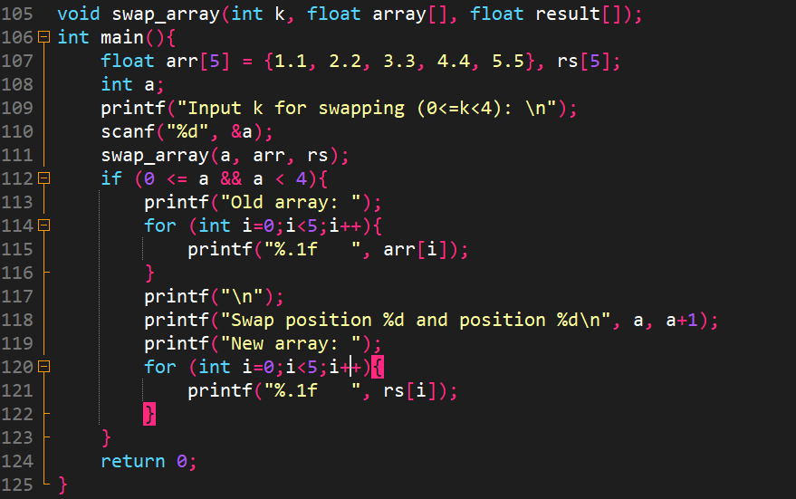

1. Test:

* Case 1:

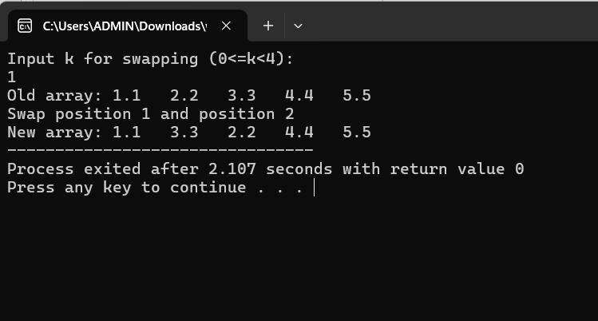

Walkthrough:

Line 110: enter 1 🡪 a =1

Line 111: pass a, arr, rs to swap_array function

Line 129: true 🡪 execute condition command 🡪 establish “temp” variable to swap

Line 136: store values of array into result

Line 120: print out on screen new array

* Case 2:

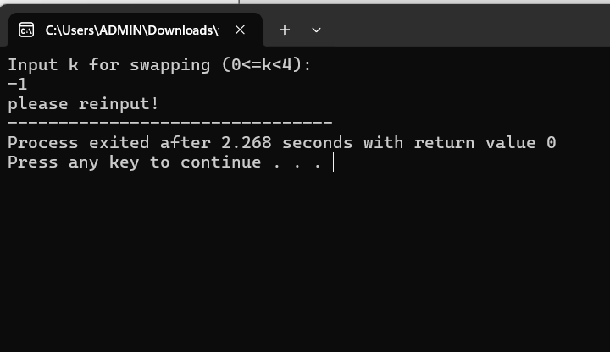

Walkthrough:

Line 110: enter -1 🡪 a =-1

Line 111: pass a, arr, rs to swap_array function

Line 129: false 🡪 execute else command 🡪 print out on screen “please reinput”